CNN Model Execution for Image Classification

**Upload data**

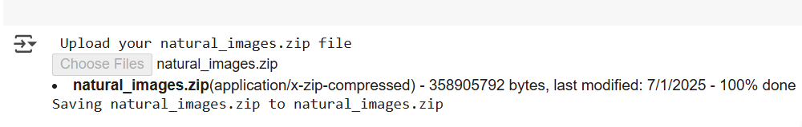

**Classes tagged**

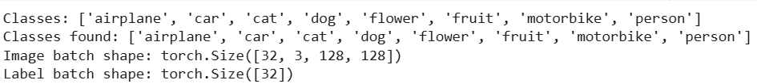

**Train Data**

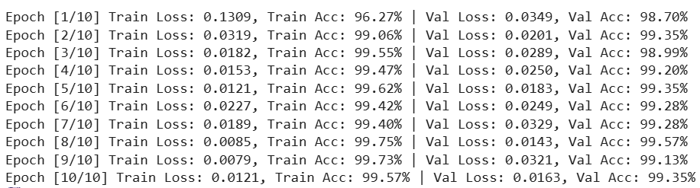

**Look for Loss and accuracy over epochs**

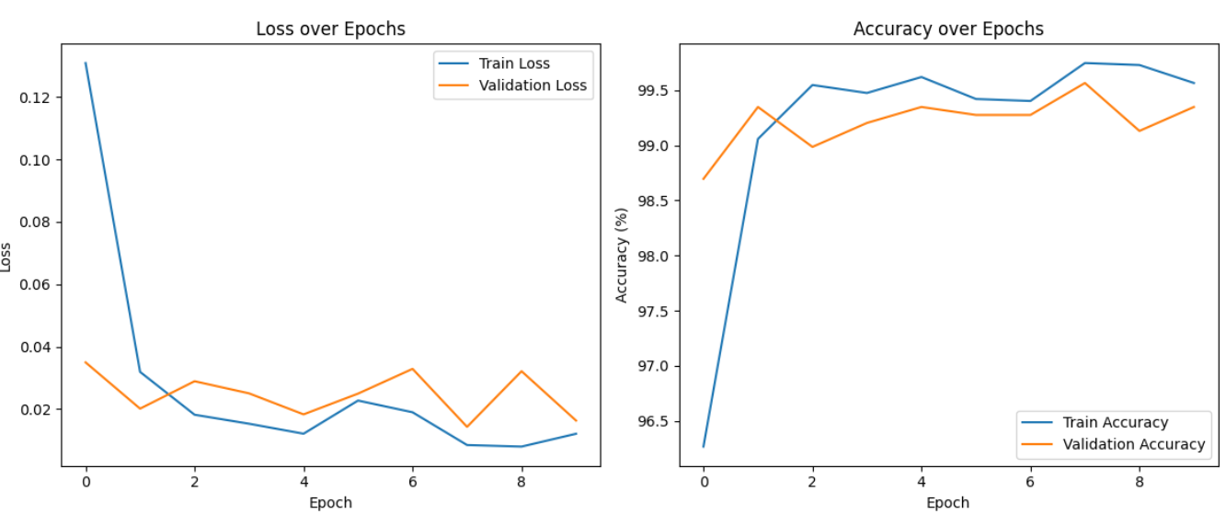

**Validation Accuracy: 99.13%**

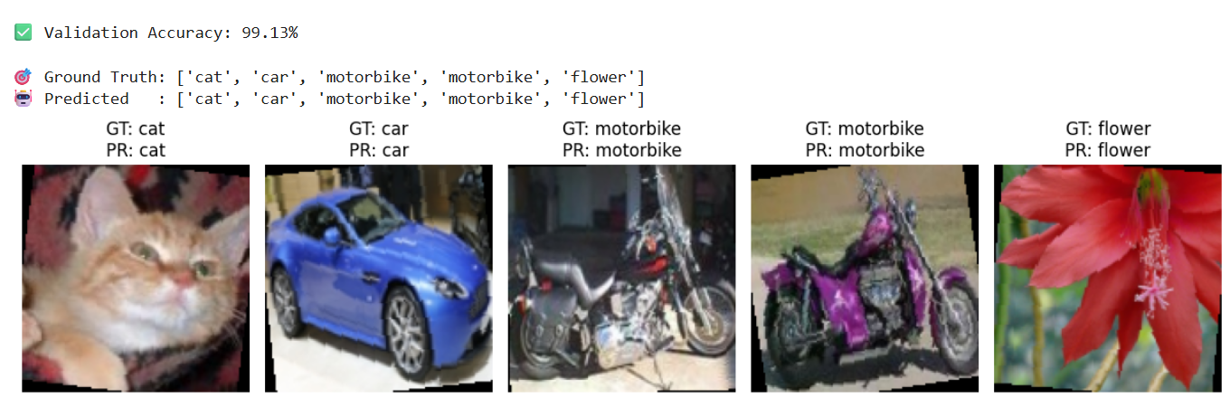

**Confusion Matrix**

